Requirements Intelligence Chatbot (RIC)

  - Executive Summary
The problem. When a union labor agreement is renegotiated, the change reaches the business as a plain-language memo (an IOC). An analyst must then figure out which of hundreds of timekeeping rules that memo affects. The memo is written for store managers, not for system configuration — so it never names the rules, the labor-agreement codes, or the requirement IDs the analyst actually works with. Today this translation happens by hand, from memory, against a large and densely written inventory. Skilled analysts do it well, but rules occasionally get missed — and a missed rule becomes a payroll error.
The solution. The Requirements Intelligence Chatbot reads the IOC and the current requirements inventory and produces a reviewed-by-a-human impact analysis: which rules the change touches, how complex the change looks, and what needs clarifying before anyone edits. It is a decision-support tool, not an automation tool — it never edits the inventory. The analyst stays fully in control; the tool's job is to make sure nothing is overlooked before they begin.
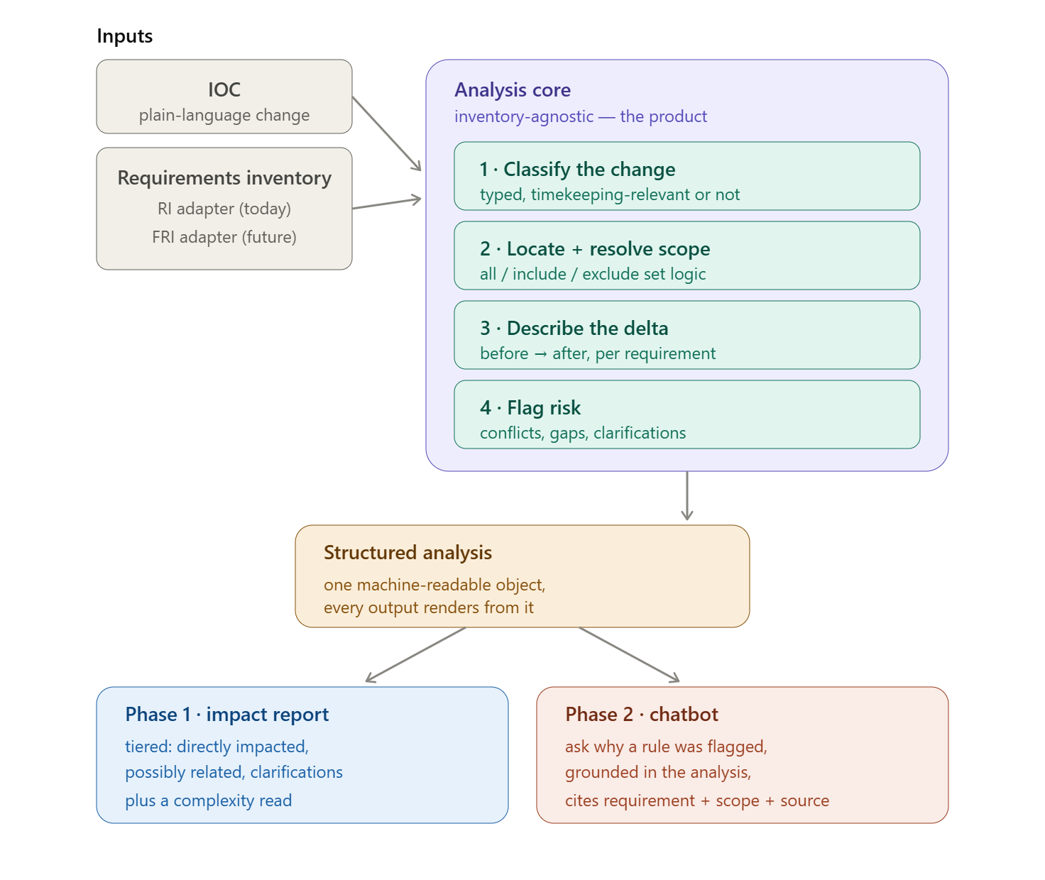
The IOC and inventory feed a central analysis core; the core produces a structured analysis rendered as a report (phase 1) and a chatbot (phase 2).
Why it works. The tool is deliberately tuned for completeness over precision. Flagging one rule too many costs an analyst seconds to dismiss; missing one costs a payroll defect. Its most valuable single capability is resolving the inventory's "include / exclude" scope logic — the exact place a human skims a rule, sees unfamiliar codes, and wrongly skips it. A computer never makes that inversion.
Proven on real data. Run against a real IOC and inventory, the tool caught findings a rushed analyst could miss: a holiday change that touched two rules in different sections rather than one, a sick-leave change that mapped to an existing rule, and an open question in the inventory that the IOC actually answered.
The plan. Phase 1 delivers the analysis as a structured report and proves it can be trusted. Phase 2 adds the conversational chatbot — grounded in that validated analysis — plus scale across the full inventory library. The architecture is built to carry the organization's move from the current Workbrain-based inventory (RI) to its application-agnostic successor (FRI) without a rewrite.
What we need to confirm. Two dependencies: the existing contract-to-labor-agreement mapping (already available), and whether the future FRI will store rule details in a more structured form than today's free-text inventory.

  - Glossary
IOC — Inter-Office Communication. The plain-language memo that Legal/HR sends out after a labor agreement is negotiated and ratified, announcing the change to store managers. It is the tool's starting input. Written for a business audience, so it describes changes in everyday terms rather than in system or requirement identifiers.
RI — Requirements Inventory. The catalog of timekeeping rules that drives configuration in the current system (Infor Workbrain). Structured around Workbrain's calc-group model. The authoritative inventory today.
FRI — Foundational Requirements Inventory. A re-expression of the same requirements in an application-agnostic form, decoupled from Workbrain, so the rules survive a future move to a different application. The forward-looking successor to the RI. Both RI and FRI are requirements inventories; they differ in what they are structured around.
LA — Labor Agreement. A union contract governing a group of employees. Identified by a six-character code (for example 1400WA, 1401PM). Each rule in the inventory specifies which labor agreements it applies to. Not to be confused with a Contract ID, which is the shorter four-character form (for example 1400, 1401); one contract maps to one or more labor agreements.
HNW — Holiday Not Worked. A category of pay rule covering holiday pay for employees who do not work the holiday. It appears often in the sample inventory and is used in the spec as an example of a rule category a change might touch.
BRD — Business Requirements Document. A business-readable requirements write-up sometimes produced from an IOC. Mentioned in the spec as an output deliberately excluded from the current scope.
Calc group — Calculation group. A Workbrain structural concept the RI is organized around. Relevant because the FRI exists specifically to break the dependency on it.
WFM — Workforce Management. The functional domain this tool serves — the systems and rules governing employee time, attendance, scheduling, and pay.

Requirements Intelligence Chatbot (RIC) — Design Specification

  - 1. Introduction
When a labor agreement is negotiated or renewed, the change is communicated to the business through an Inter-Office Communication (IOC). A business analyst then has to work out how that change affects the organization's requirements inventory — the catalog of timekeeping rules that drives system configuration. Today this analysis is done from memory and manual reading. Analysts are skilled, but the inventory is large and the IOC is written in plain business language that doesn't line up with how the inventory is organized, so impacted requirements are occasionally missed. A missed requirement becomes a configuration defect that surfaces in payroll.
The Requirements Intelligence Chatbot is a decision-support tool, not an automation tool. It reads an IOC and the current requirements inventory, and produces a human-reviewed impact analysis: which requirements the change touches, how complex the change looks, and what needs clarification before anyone edits. The analyst stays fully in control — the tool never edits the inventory. Its job is to ensure nothing is overlooked before the analyst starts, and to surface the questions that should be asked up front.
The core value is completeness. The tool is deliberately tuned to catch every potentially impacted requirement, accepting that it will sometimes flag one that turns out not to matter. An analyst dismissing an irrelevant suggestion costs seconds; a missed requirement costs a payroll error. That trade-off shapes the entire design.
The product's end state is an interactive assistant that analysts can question directly about a change and its impact. Because a conversational answer is only as reliable as the analysis beneath it, the capability is built in two stages: the analysis core and its structured impact report first, and the conversational interface layered over that validated core once it is trusted. This specification details the analysis core (phase 1) in full and defines how the conversational layer (phase 2) builds on it.
  - 2. Two requirements inventories: RI and FRI
The organization maintains its timekeeping requirements in two related but distinct forms, and the tool must understand both.
The Requirements Inventory (RI) is the original artifact. Its structure is tied to Infor Workbrain, the current enterprise Time and Attendance system — specifically to Workbrain's calc-group structure, because the requirements were written to drive that application's configuration. The RI is authoritative today but application-bound.
The Foundational Requirements Inventory (FRI) is the contract analysts' effort to re-express those same requirements in an application-agnostic form, deliberately decoupled from Workbrain's structure. Its purpose is portability: when the organization migrates to a different application, with different configuration items, the requirements should not have to be reverse-engineered out of a Workbrain-shaped inventory. The FRI is the forward-looking, durable version.
Both are requirements inventories serving the same fundamental role; they differ only in what they are structured around. The stated direction is for the FRI to become the primary inventory, with the RI as the legacy source. However, there is no fixed timeline for retiring the RI, and today many labor agreements have an RI but no FRI. The tool must therefore treat RI/FRI coexistence as a normal, indefinite operating condition — not a migration edge case. This is an architectural constraint on phase 1, addressed directly in section 4.
  - 3. The problem, precisely
The difficulty is not that changes are complicated to make — analysts make edits confidently. The difficulty is in the analysis step that should happen first: surveying the full blast radius of a change across a large, densely written inventory.
Three properties of the documents make this hard. First, the IOC is written for store managers, not for timekeeping configuration. It describes a change in plain business language ("pharmacy staff get a higher Sunday premium") rather than in requirement identifiers or labor-agreement codes. Second, the IOC is under-specified by design — it may give an effective date without saying which of several dates governs the timekeeping change, or name a population without listing the labor agreements. Third, a single IOC bundles many changes across many domains — wages, benefits, pension, operational provisions — and only some touch timekeeping at all, so the analyst must triage relevance before matching anything.
A real example illustrates all three. The IOC for contracts 1400/1401 (073 GrocWorks union drivers, labor agreements 1400WA and 1401PM) is six pages covering pension, health and welfare, a third-party delivery arrangement, tipping, vacation accrual, jury duty, and funeral leave — most of which never touches timekeeping — alongside a few changes that do: a holiday-worked premium change, a holiday-week composition change, and a new job classification. Buried in the benefits language is a sick-leave change (a Seattle ordinance now applying) that does affect the inventory. Finding those few needles, then mapping them to specific requirements, is the manual work that leads to misses.
  - 4. Architecture: an inventory-agnostic core with input adapters
Because RI/FRI coexistence is indefinite, the tool must not be built "against the RI" with FRI added later. The core analysis engine operates on an abstract, inventory-agnostic representation of a requirement — its identity, its scope, the change delta, and its configuration metadata (hour types, earn codes, effective conditions). The RI and the FRI are each an input adapter that reads its particular structure and normalizes it into this shared representation. The Workbrain calc-group shape of the RI lives entirely inside the RI adapter and never reaches the reasoning core.
This is the decision that lets the tool survive the migration. The analysis engine, the scope logic, the output tiering, and the clarification routing are all written once, against the abstract representation. Supporting the RI today means writing the RI adapter; making the FRI primary later means maturing the FRI adapter. Neither touches the engine. For any given labor agreement, the tool uses whichever inventory is available — in practice the RI today, the FRI as it comes online, and either when both exist.
This architecture also yields a valuable capability once both inventories exist for a labor agreement: the tool can run the same IOC against both and verify the impact analysis agrees — that a change lands on corresponding requirements in each. This is a built-in consistency check on the FRI re-creation effort, surfacing places where the FRI has drifted from or failed to capture what the RI encodes. It is deferred beyond phase 1, but the inventory-agnostic core is what makes it possible at no extra structural cost.
  - 5. The central concept: analysis, not documents
The most important design decision is what sits at the center of the system. It is not the IOC and not the edits — it is the structured analysis in between: a machine-readable understanding of what changed, for which population, in what way, with what remaining uncertainty. Every output is a rendering of that analysis. Keeping it explicit, rather than jumping straight from IOC text to a list of requirements, is what makes the tool reviewable rather than a black box, what makes it inventory-agnostic (section 4), what will make the conversational layer safe (section 7), and what would let a business-readable rendering be added later without redesign.
  - 6. How the analysis works
The pipeline has four stages, and the difficulty is not spread evenly.
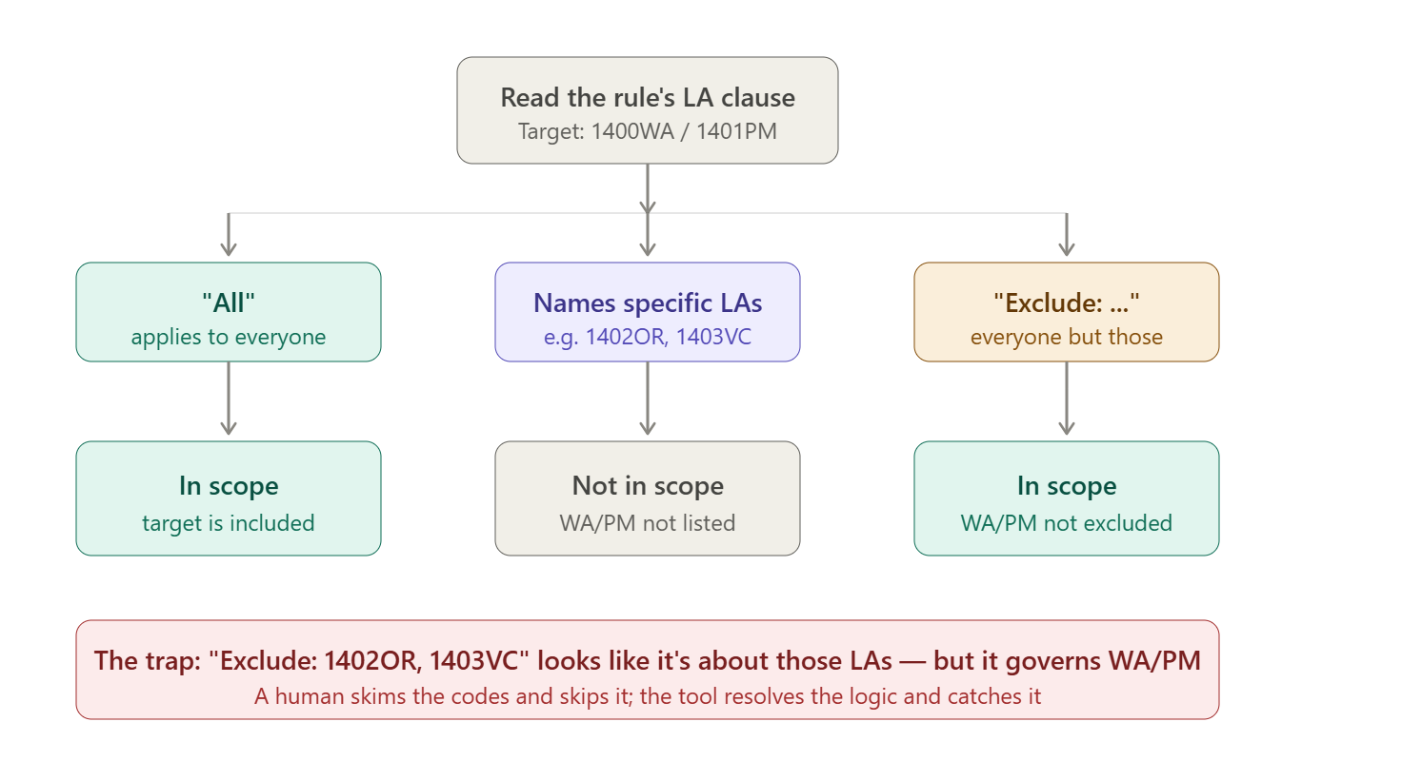

The first stage classifies each change in the IOC. The IOC is decomposed into discrete changes, each categorized — a premium value change, a list operation (adding or removing a labor agreement or job code), an eligibility change, a rate change, a holiday-composition change — and tagged for timekeeping relevance. This turns an open-ended document into a set of bounded, typed changes, which makes everything downstream tractable. It is worth building and testing this stage first, in isolation, because everything after it inherits its quality.
Before matching, the tool normalizes identifiers. Contract IDs are four-character strings (1400, 1401); labor agreements are six-character strings (1400WA, 1401PM). An IOC may reference either. The organization maintains an existing mapping between contracts and labor agreements, and the tool uses it to resolve any contract reference to its constituent labor agreements and vice versa. This is a known lookup, not an open problem.
The second stage locates the affected requirements. This is the hardest stage, because the IOC cannot cite requirement identifiers. The tool matches by meaning and by contract reference, using both signals to keep recall high: semantic similarity between the change and each requirement's description, and the Contract Reference field, which ties each requirement back to a clause of the agreement, so a change can be cross-checked against requirements pointing at the same clause.
Within this stage sits the single most important piece of logic in the system: labor-agreement scope resolution. Each requirement declares its scope in one of three forms, and the tool must resolve all three against the change's target labor agreements. "Labor Agreement(s): All" applies to every agreement. A named list — "Labor Agreement(s): 1402OR, 1403VC" — applies only to those. "Exclude: 1402OR, 1403VC" applies to everyone except those, which for a 1400WA/1401PM change means it does apply.
That exclude case is the trap the tool exists to catch. A requirement reading "Exclude: 1402OR, 1403VC" looks, to a skimming human, like a requirement about Oregon and VC — so an analyst pattern-matches on those codes and skips it, when in fact it is precisely the requirement governing their Washington/PM change. A computer resolving the set logic never makes that inversion. This one check likely justifies the tool on its own. The requirement is that the tool parse the all/include/exclude language for every requirement and determine in-scope status by set logic, never by surface keyword matching.
The third stage describes the delta for each impacted requirement: current state, proposed new state, and the reason it is affected — anchored to the requirement's identifier so the output is precise. The fourth stage flags risk: potential conflicts, gaps where the IOC is silent, and clarification questions where the IOC is under-specified.
  - 7. The output the analyst sees
The analyst receives a tiered impact map, and the tiering is essential to adoption. Over-surfacing catches misses, but past a certain volume it becomes noise that analysts learn to ignore, recreating the original problem. The output separates a confident tier of directly impacted requirements from a secondary tier of possibly-related requirements to check, from a set of flagged clarifications. Attention goes to the confident tier first; the secondary tier is present enough to catch a miss but quiet enough not to drown the signal.
Each impacted requirement carries both a plain-language statement of the change and the precise mechanical detail — the requirement identifier, current text, proposed change, and affected hour types and earn codes — because the output serves two readers in sequence. The business analyst checks whether the tool understood the change correctly; the IT/configuration analyst checks whether the proposed change is technically correct against the inventory and the target application. One reads the top of each item, the other the bottom.
Two further outputs layer onto the same analysis. A complexity read gives the analyst a heads-up on effort before they begin — a change touching one requirement for one scope is easy; a change touching premium, holiday, and rate requirements across multiple scopes with a retroactive effective date is hard. And clarification questions are routed to where they belong: the inventory already contains separate Questions/Comments columns per jurisdiction (in the 073 file, one for Oregon labor agreements and one for Washington), so the tool's flagged questions pre-populate an existing artifact rather than inventing a new one. In the worked example, the tool matched the IOC's July 1, 2024 ratification date to a holiday-not-worked requirement whose Washington column already asked "what is the ratification date of this contract?" — closing a question the analysts had written down themselves.
Delivery surface: report first, conversation second. The structured analysis is the product; how it is presented is a separate layer. In phase 1 it is rendered as the tiered impact report described above. In phase 2, the same analysis object is exposed through a conversational interface — the chatbot from which the product takes its name — so analysts can interrogate it directly, asking why a requirement was flagged, which requirements a category of change touches, or what a specific delta means in configuration terms. The conversational layer is an interpretation layer over the analysis, not a re-analysis: every answer it gives must be grounded in and traceable to the structured analysis — the requirement identifier, the resolved scope, and the source clause behind each finding. It must not introduce requirements or conclusions that aren't in the analysis. This grounding discipline is the central design rule for the conversational layer, and the reason it is built only after the analysis core is validated. The two-audience need is served naturally here: the business analyst and the IT/configuration analyst can each question the same analysis in their own terms, and clarification becomes interactive — the chatbot can pose its clarifying questions to the analyst and fold the answers back into the analysis.
  - 8. What the tool caught on real data
Running the 1400WA/1401PM IOC against the 073 E-Commerce RI produced several findings a rushed analyst could plausibly miss — the concrete evidence the concept works. It found that the MLK/anniversary holiday-week change touches two requirements in different categories, not one, because the anniversary date lives in the Holiday Leave balance requirement rather than the holiday-not-worked list. It connected the IOC's ratification date to the open question already sitting in the inventory. It identified that the sick-leave change maps to an existing Sick Ordinance requirement whose Seattle-waiver exclusion the IOC removes. And it correctly resolved scope: the requirements in scope for this change are all those marked "All" plus all those marked "Exclude: 1402OR, 1403VC," and none of the requirements naming 1402OR/1403VC specifically.
  - 9. Design considerations and constraints
Requirement metadata — labor agreements, hour types, earn codes, scope — lives inside free-text description cells in the RI rather than in dedicated columns, so the RI adapter must extract this from prose. The text follows a consistent internal pattern (statement, then hour types and earn codes, then the labor-agreement clause), which makes extraction reliable, but it remains an extraction task to be tested. Whether the FRI carries this metadata in a more structured form is an open question worth confirming with the contract analysts, as it would simplify the FRI adapter and ease the eventual migration — and it is worth confirming now, while the FRI is still being designed.
The contract-to-labor-agreement mapping is a dependency the tool relies on; it should be sourced from the organization's existing mapping and kept current, since a stale mapping would cause the tool to normalize identifiers incorrectly.
The conversational layer (phase 2) carries its own principal risk: staying grounded. A fluent but wrong answer is more dangerous than a wrong line in a report, because it carries more apparent authority. The mitigation is architectural — the chatbot answers only by querying the structured analysis and cites the requirement, scope, and source behind each answer — and procedural: it is built only after the phase-1 analysis is validated.
  - 10. Phased delivery
Phase 1 is the analysis tool: the inventory-agnostic core with an RI adapter, producing the tiered impact report, complexity read, and clarification questions, delivered as a structured report. This phase proves the analysis is trustworthy — the precondition for everything that follows.
Phase 2 introduces the conversational interface — the chatbot from which the product takes its name — as a grounded interrogation layer over the phase-1 analysis, together with the scale-and-trust capabilities: indexing the full inventory library so an IOC can be matched across all inventories rather than one file at a time (where semantic retrieval earns its place), version tracking, an evaluation harness, and the RI/FRI consistency check as the FRI comes online. Evaluation deserves emphasis: historical IOCs and their resulting inventory states are a ready-made test set, because each past change is effectively a solved case the tool's output can be checked against. This needs past examples, not labeled training data.
A later phase revisits outputs deferred from phase 1: rendering a business-readable document from the same central analysis, and extending upstream to assist in drafting the analysis from rawer inputs — understanding that upstream generation is a reconstruction problem, to be built as assisted drafting with strong clarification prompts, never full automation. Maturing the FRI adapter as the FRI becomes primary also lands here, and by design requires no change to the analysis core.
  - 11. Guiding principles
The tool proposes; the analyst disposes. It is tuned for recall over precision, because a missed requirement is the failure that matters. It resolves scope logic rather than matching keywords. It keeps a structured, inventory-agnostic analysis at its center so its reasoning stays inspectable, its outputs stay extensible, and it survives the RI-to-FRI migration. The conversation is grounded in the analysis, never free-floating: the chatbot answers by querying the structured analysis and cites the requirement, scope, and source behind every answer, and is built only after the analysis it speaks for is trusted. And it treats the existing structure of the inventories — requirement identifiers, contract references, per-jurisdiction question columns, include/exclude scoping — as the design's foundation rather than working around it.

RIC — Extraction Schema (Companion Technical Document)

  - Purpose
The analysis engine reasons over two structured objects: a Requirement (one per rule in the inventory) and a Change (one per discrete change in the IOC). This document defines the fields of each. These objects are the contract between the input adapters and the analysis core — the adapters produce them, the engine consumes them, and nothing downstream reads raw document text. Getting these right is the first build task.
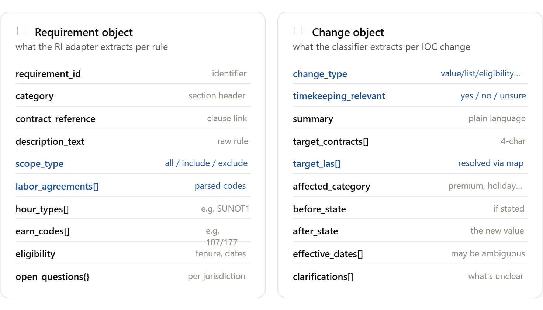
The two objects side by side; highlighted fields are the highest-risk, highest-value extractions.
  - The Requirement object
One is produced per rule by the inventory adapter (the RI adapter today). The RI stores most of these fields inside a single free-text description cell, so the adapter's real work is parsing that prose into structured fields.
The requirement_id is the rule's identifier where present. Note that many rows in the sample RI leave this blank (the ID sits on a category header row, with several rules beneath it), so the adapter must handle inheritance or positional identity — the developer should confirm how IDs associate with rules.
The category is the section the rule sits under (Sunday Premium, Holiday Not Worked, Shift Premiums), read from the header rows that group the inventory.
The contract_reference is the clause link (for example "Pg 6 Article 3, 3.01"), used as a second matching signal alongside description similarity.
The description_text is the raw rule language, retained verbatim so the tool can quote it and so nothing is lost in parsing.
The scope_type and labor_agreements[] are the two most important fields in the schema. Together they encode who the rule applies to. scope_type is one of all, include, or exclude, parsed from the "Labor Agreement(s)" clause. labor_agreements[] is the list of six-character codes named in that clause. A rule marked "All" has scope_type all and an empty list; "1402OR, 1403VC" has scope_type include and those two codes; "Exclude: 1402OR, 1403VC" has scope_type exclude and those two codes. The engine determines whether a rule is in scope for a change by set logic over these two fields — never by keyword matching — which is what catches the exclude-inversion trap.
The hour_types[] and earn_codes[] are the configuration identifiers embedded in the rule text (hour types like SUNOT1, earn codes like 107/177). They follow a consistent internal pattern, which makes extraction reliable.
The eligibility captures tenure and date conditions where present (for example "eligible after 6 months", "hired on or after 09-14-2020").
The open_questions{} is a per-jurisdiction map, populated from the inventory's Questions/Comments columns (in the sample RI, one column for Oregon labor agreements and one for Washington). This is both an input the tool reads and the destination where the tool writes its own clarification questions.
  - The Change object
One is produced per discrete change by the IOC classifier.
The change_type is the classification — a value change, a list operation (add or remove a labor agreement or job code), an eligibility change, a rate change, a holiday-composition change, and so on. This tag tells the downstream stages what kind of delta to look for.
The timekeeping_relevant flag is yes, no, or unsure. This is the triage that separates the few timekeeping-relevant changes from the many that belong to benefits, pension, or operations. The unsure value routes a change to the clarification tier rather than forcing a wrong call.
The summary is a plain-language restatement of the change, for the business-analyst reader.
The target_contracts[] and target_las[] hold the change's scope. An IOC may name either four-character contract IDs or six-character labor agreements; the classifier records whatever is stated in target_contracts[], and target_las[] holds the labor agreements after resolving contracts through the organization's existing contract-to-LA mapping. The engine matches against target_las[], so this normalization must happen before scope resolution.
The affected_category is the rule category the change most likely touches (premium, holiday, overtime), used to focus the search.
The before_state and after_state capture the change itself — the prior value if the IOC states it, and the new value. For many IOC changes before_state is absent, because the memo only states the new terms; that absence is expected and is itself a signal.
The effective_dates[] holds the dates associated with the change, and is deliberately a list because IOCs routinely carry several (contract-effective, wage-effective, ratification) without saying which governs the timekeeping change. When more than one is present, the engine raises a clarification rather than guessing.
The clarifications[] is the list of things the classifier judged unclear about this change — the seeds of the clarification output.
  - Notes for the build
Both objects should be validated against the sample documents before the engine is written — parse the 073 RI into Requirement objects and hand-check that scope_type and labor_agreements are correct on the include, exclude, and all cases, since everything depends on those. The classifier should be tested in isolation against past IOCs for change_type and timekeeping_relevant accuracy before it is wired to the matcher.
One open question for the team affects this schema directly: whether the future FRI stores these fields (scope, labor agreements, hour types, earn codes) as structured columns rather than embedded in free text. If it does, the FRI adapter becomes far simpler — it reads fields rather than parsing prose — and the schema above is already the target shape it would populate.

